Audio lesson for Apple

There are several ways to use a apple product for audio purposes where are a few with a demonstration.

Siri

Let's ask her a question?

I movie

Do you have a kid with anxiety the. Here let's look at a presentation done with I movie.
Jessie the clown

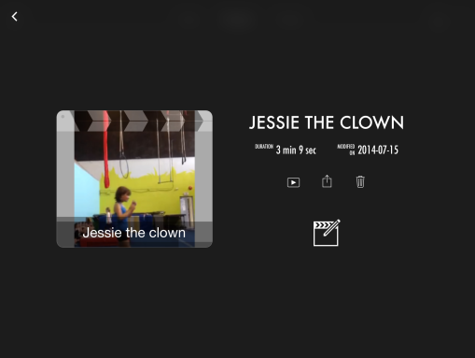
Text to speech with natural read
I have a son with dyslexia so I have been looking for phonics and other apps, this one I used a sustainability article
Demo the read ability with response paper

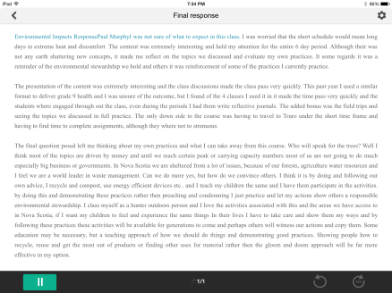

My favourite for making repetitive teaching easier especially with byod
Educreations,

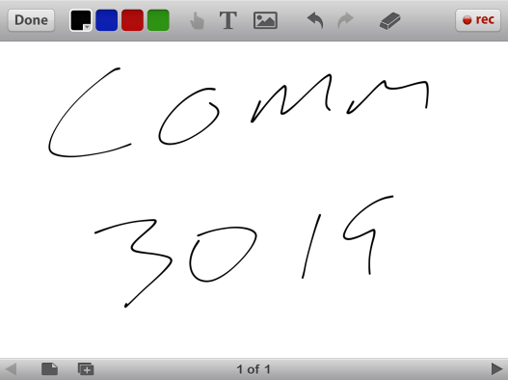
Smart board with many more applications and instant storage for recall.

